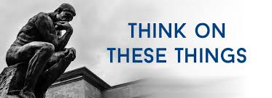

**PASSPORTS**

“A passport is used to verify one's country of citizenship.” This is the definition of a passport. It is for the purpose of identity. To be a citizen of any country, there are specific requirements that must be met, unless the country is the place of birth. To prove one’s citizenship, a passport is issued.

I have never travelled outside of the USA, so I have never needed a passport. But, there is another kind of citizenship that is very important. Paul wrote: *“But our citizenship is in heaven. And we eagerly await a Savior from there, the Lord Jesus Christ,”* (Philippians 3:20).

Just as a passport is needed to prove one’s identity, so as a Christian we are to prove our identity. The word “Christian” has been used to refer to many things. It is often used as an adjective to identify something. For example, we talk about a “Christian home,” or a “Christian family,” etc.

Actually, the word “Christian” in the New Testament is always used as a noun, descriptive of individuals. The above verse mentions our “citizenship” which is in heaven. But how do we identify ourselves as “Christians”? What is our “passport”? How do those around us recognize us as a Christian?

Jesus said, *By this all men will know that you are my disciples, if you love one another."* (John 13:35). Here is our badge of identification. Here is how others know that we are a Christian….by our love for one another. This is our “passport.” This is how we identify as a citizen of heaven.

Do people around your know that you are a Christian? Do you have a “passport” that identifies you as a citizen?

A

**VOLUME 25 Jan 15, 2023 NUMBER 3**

***Welcome to our services*  SUNDAY Worship…………………………………9:30 AM Bible Class……………………………10:45 AM MONDAY Bible Study……………………………6:30PM WEDNESDAY Bible Study……………………..…..7:00 PM THURSDAY W.I.N.G.S. (Women In God’s Service) Ladies’ Bible Class…………….10:00 AM**

**Monday PM, Wednesday PM and Thursday AM classes will all meet in the West Annex for the present time**

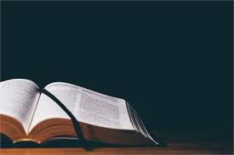

**Sermon: The Lord Of The Little**

**Charles Murray**

Friday Christians



**SKYVIEW CHURCH OF CHRIST 5972 62ND Avenue N. Pinellas Park, Fl –33782**

