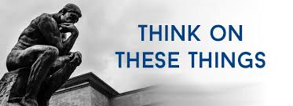

**SIGNS**

Our new LED sign has been delivered and at the time of this writing may or may not have been installed. It will be in operation very soon. But whether it is installed at this time does not affect the message of this article.

Signs have been used in the past. In fact in the Bible in the NIV the word “sign” appears 87 times. The Hebrew word, translated “sign,” means “a signal, flag, warning or monument.” The Greek word has basically the same meaning, " a warning or indication of something.”

In Luke 11 Jesus said the Pharisees were testing Him by asking for a “sign” to prove His teachings to be true. John tells about the sign Herod fastened to the cross which read, “Jesus of Nazareth, King Of The Jews.” This sign was written Aramaic, Latin and Greek. He adds that many of the Jews read this sign.

There are many other significant signs mentioned in scripture. The Book of Revelation talks about various signs. But I challenge you to think about a sign that all of need to display. This is the sign of being a Christian. I am not talking about holding up a sign on which the word “Christian” is written…I am talking about the signal or demonstration we give to others that we are a Christian. This “sign” is the life we live. It is how we think, act and react in this life. The “sign” is how we appear to other people. Do we give off any indication that we are a child of God, or do we look more like a child of the world? Isaiah said he would be sign and a witness to the Lord Almighty. May we hold up this sign.

**VOLUME 24 February 7, 2021 Number 6**

***Welcome to our services*  SUNDAY Worship…………………………………9:30 AM Bible Class……………………………10:45 AM MONDAY Bible Study……………………………6:30PM WEDNESDAY Bible Study……………………..…..7:00 PM THURSDAY W.I.N.G.S. (Women In God’s Service) Ladies’ Bible Class……………………10:00 AM**

**Monday PM, Wednesday PM and Thursday AM classes will all meet in the West auditorium for the present time**

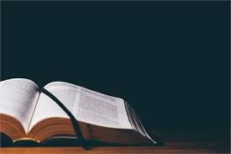

**TODAY’S SERMON: Calvin McCoy -----speaker**SERMON

Friday Christians



**SKYVIEW CHURCH OF CHRIST 5972 62ND Avenue N. Pinellas Park, Fl – PO Box 3118 33780**

