

KILLING GIANTS
One of the thrilling Bible stories we learned as children was about David killing Goliath, the Philistine giant with a sling and a stone ( 1 Samuel 17:50). To this day two timeless truths of giant warfare live on. Both are appropriate today as they were in David's day.
Truth number one: Prevailing over giants cannot be accomplished by using their technique. David did not carry a sword. He did not have an armor. His lethal weapon made him unique and gave him victory. His armor was his shield of faith.
Truth number two: Conquering giants cannot be accomplished without great skill and discipline. To be God's warrior, to fight His way demands expertise and control.
You are probably thinking, "How does this apply to me today?" It applies because we have giants we fight, often on a daily basis. Not a physical giant like Goliath, but giants just the same.
Our giants take the form of the things that cause us problems and stress in our lives. Our giants fight for the control of our mind. Some of our giants: Fear, Bitterness, Jealousy, Lust, depression, Loneliness, Resentment, Grief, Pain, Procrastination, just to mention a few. We could probably write a book to tell about our giants. Your giants may not be my giants, but we all have them.
The real question is "How do we conquer these giants?" "How can we be victorious over them?" We can learn from the Master Teacher, Jesus Christ. Think of the giants He faced while on earth. He was falsely condemned as a law breaker. He was persecuted and mistreated, and finally put to death by His own people. The very One who conquered giants was awarded with a crown of thorns.
Giants still reside in our world. But they don't have to rule. They don't have to be in control of our lives. Through Jesus, we can be more than conquerors over our giants. Giants still tremble at the name of Jesus.
We often sing a song that expresses this truth. "Victory In Jesus." That is the only way we can kill our giants. That is the only way we can be victorious over them. Allow Jesus to be your armor and your shield against your giants.

WELCOME TO OUR SERVICES
SUNDAY
Worship.....................................................9:30 AM
Bible class...............................................10:50 AM
MONDAY
Bible study................................................6:30 PM
WEDNESDAY
Bible class.................................................7:00 PM
THURSDAY
Ladies Bible Class.................................10:00 AM
(These meetings are all at the building)
SKYVIEW CHURCH OF CHRIST
VOLUME 24 February 2, 2020 NUMBER 5
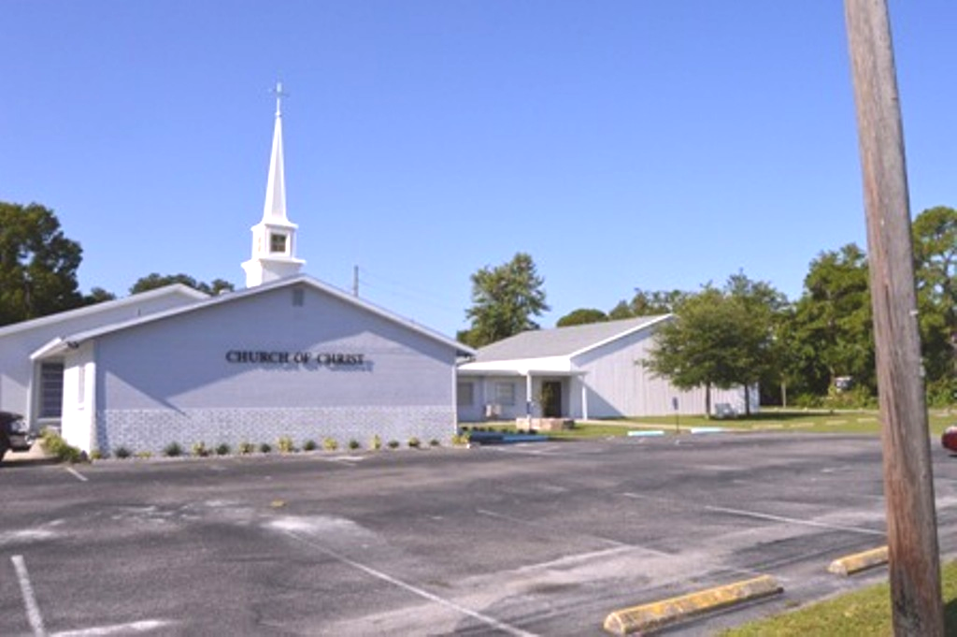

TODAY'S SERMON
"God Can Do It"
No evening service



ORDER OF SERVICES
Sunday, March 17, 2019
Call To Worship..............Drew Murray
Opening Prayer.......Denning Andrews
Song Leader...............Derrick Cowan
Song # 231 Soldiers Of Christ Arise
Song # 499 I Want To Be A Worker
Song # 251 I'm Happy Today
COMMUNION
Head Table......................Andy Murray
Song # 307 Are You Washed
Scripture: Wilson Birdwell Phil 3:12-15
Sermon........................Charles Murray
In Song # 273 I''m Not Ashamed
Closing prayer................Harry Cowan
Announcements............Don Greenlee

Wednesday, March 20, 2019
Song Leader....................Andy Murray
Invitation............................Jim Ingram
Closing prayer..............Art Whitehead
Announcements...........Don Greenlee

ORDER OF SERVICES
Call to worship...............Andy Murray
Opening prayer.............Harry Cowan
Song Leader ........Shaun Whitehead
Song # 37 Revive Us Again
Song # 202 Beyond This Land Of
Partin
. Song # 163 In Remembrance
COMMUNION
Head table....................Drew Murray
Song # 258 Home Of The Soul
Scripture.......................Gailand Kiltz
Sermon................. .Charles Murray
In Song # 279 He Is Able....
Closing prayer................. Henry Oliu
Announcements ...Denning Andrews

Wednesday, May 22, 2019
Song Leader...................Jim Ingram
Invitation.......................Andy Murray
Closing prayer...................Joe Dryer
Announcements..........Drew Murray

SERVING THE CONGREGATION
ELDERS
Don Greenlee....................541-1534
Jim Ingram........................525-3636
Charles Murray.................709-2799
DEACONS
Andy Murray......................709-5364
Pat Skidmore.............740-612-9466
Art Whitehead...................561-2799
MINISTER
Charles Murray..................709-2799

WHO TO CALL
Benevolence..........Andy Murray, Art Whitehead
Finances........Don Garner-Treasurer
Technology...........Andy Murray, Jim Ingram (Website, recording)
Directory........................Andy Murray
Calendar...................Charles Murray
Worship Schedule........Chas. Murray
Web Site...................Charles Murray

