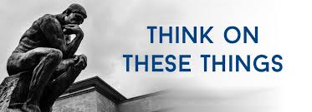

**THE KINGDOM OF CHRIST**

Everyone lives within a system of power. We are under the rule of a President, King, Parliamentary leader, or some other form of government. In this systems of power created by man, some have more influence than others and therefore are considered to have more value.

But Jesus instituted a completely different system of power where everyone is considered equal in value. In His system, power and authority are in the hands of the most generous and kindest leader who ever lived.

God’s kingdom does not elevate the rich, the healthy, or the most powerful. In fact, it does the opposite. It cares for the poor, it heals the broken and frees the enslaved. The kingdom of God is “good news” for everyone. Jesus, as He began His ministry quoted the prophet Isaiah*: “The Spirit of the Lord is upon Me, because He has anointed Me to preach the gospel to the poor; He has sent Me to heal the brokenhearted. To proclaim liberty to the captives and recover sight to the blind, to set at liberty those who are oppressed*…..” (Luke 4:18-19).

Christ is the embodiment of God’s kingdom, and those who are Christians are living in that kingdom now. The principles set forth by Jesus in the quote from Isaiah apply to us. The truth Jesus brought is the same for us today: We are healed. We are accepted. We are free.

What a wonderful blessing to be in the Kingdom of God.

**VOLUME 24 November 21, 2021 Number 47 414401**

***Welcome to our services*  SUNDAY Worship…………………………………9:30 AM Bible Class……………………………10:45 AM MONDAY Bible Study……………………………6:30PM WEDNESDAY Bible Study……………………..…..7:00 PM THURSDAY W.I.N.G.S. (Women In God’s Service) Ladies’ Bible Class…………….10:00 AM**

**Monday PM, Wednesday PM and Thursday AM classes will all meet in the West Annex for the present time**

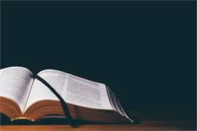

**Sermon: BEING THANKFUL IN DIFFICULT TIMES**

Friday Christians



**SKYVIEW CHURCH OF CHRIST 5972 62ND Avenue N. Pinellas Park, Fl – PO Box 3118 33780**

