

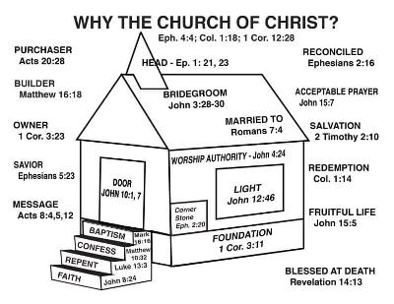

**VOLUME 24 July 11, 2021 Number 28**

***Welcome to our services*  SUNDAY Worship…………………………………9:30 AM Bible Class……………………………10:45 AM MONDAY Bible Study……………………………6:30PM WEDNESDAY Bible Study……………………..…..7:00 PM THURSDAY W.I.N.G.S. (Women In God’s Service) Ladies’ Bible Class…………….10:00 AM**

**Monday PM, Wednesday PM and Thursday AM classes will all meet in the West Annex for the present time**



**Sermon:**

**JESUS IS THE ANSWER**

Friday Christians



**Submitted by Jim Ingram**

**SKYVIEW CHURCH OF CHRIST 5972 62ND Avenue N. Pinellas Park, Fl – PO Box 3118 33780**

